Title: Implementation of Multi-Routing Protocols and Centralized Control Router as an Alternative to VXLAN
Author: Mahmoud Bahnsey

Abstract
Modern enterprise networks require scalability, flexibility, security, and efficient communication between multiple network segments. Technologies such as Virtual Extensible LAN (VXLAN) are widely adopted in Software Defined Networking (SDN) and cloud infrastructures to overcome the limitations of traditional VLANs.
However, Cisco Packet Tracer does not fully support VXLAN implementation. Therefore, this project presents an alternative network architecture that simulates many of VXLAN's functional objectives using multiple dynamic routing protocols integrated through a centralized router.
The implemented network combines OSPF, EIGRP, and RIP Version 2 with route redistribution, centralized routing, SSH secure management, Access Control Lists (ACLs), VTP, VLANs, Trunking, and security banners.
The project demonstrates how multiple isolated routing domains can communicate securely while maintaining centralized control over the entire infrastructure.

Table of Contents
- Introduction
- Problem Statement
- Project Objectives
- Network Design
- Network Components
- Routing Protocols
- OSPF Configuration
- EIGRP Configuration
- RIP Version 2 Configuration
- Route Redistribution
- Central Router Design
- Secure Remote Access
- ACL Implementation
- VLAN & VTP
- Network Verification
- Results
- Future Improvements
- Conclusion

1. Introduction
Large-scale enterprise networks consist of multiple departments, remote branches, and geographically distributed offices. These environments require efficient routing mechanisms capable of exchanging information quickly while maintaining network scalability and security.
Traditional VLANs are limited by Layer-2 boundaries. VXLAN was introduced to extend Layer-2 networks over Layer-3 infrastructures using encapsulation.
Since Cisco Packet Tracer currently lacks VXLAN support, this project proposes an alternative implementation based on dynamic routing protocols interconnected through a centralized router.
The objective is not to replace VXLAN completely, but to simulate its logical segmentation and centralized communication model using technologies supported by Cisco Packet Tracer.

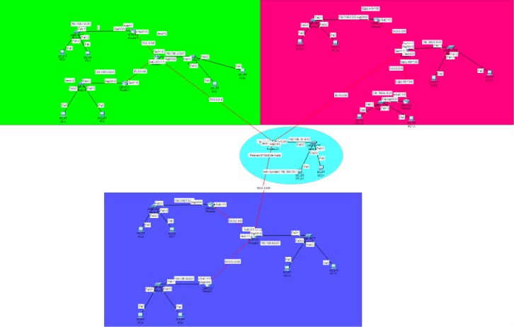

2. Problem Statement
Packet Tracer does not support modern Data Center technologies such as:
- VXLAN
- EVPN
- SDN Controllers
- Cisco ACI
Therefore, an alternative architecture was designed using traditional routing technologies capable of providing:
- Network segmentation
- Dynamic routing
- Secure communication
- Centralized traffic management
- Protocol interoperability

3. Project Objectives
The project aims to achieve the following objectives:
• Implement multiple routing protocols.
• Configure OSPF.
• Configure EIGRP.
• Configure RIP Version 2.
• Design a centralized routing architecture.
• Perform route redistribution.
• Enable secure SSH remote management.
• Configure ACLs.
• Configure VLANs.
• Configure VTP.
• Configure Trunk Ports.
• Configure warning banners.
• Verify network connectivity.
• Simulate enterprise network behavior.

4. Network Design
The network consists of several routing domains connected through one centralized router responsible for interconnecting all networks.
Instead of allowing direct communication between routing domains, all traffic passes through the Central Router.
This architecture simplifies administration while improving visibility over network traffic.

5. Network Components
The project includes:
• Cisco Routers
• Cisco Switches
• End Devices
• Serial WAN Links
• Gigabit Ethernet LAN Links
• Central Router
• SSH Management Interface
• ACL Security Policies
• VLAN Infrastructure

Software Used
• Cisco Packet Tracer
• Cisco IOS CLI
• Dynamic Routing Protocols
• SSH
• ACL
• VLAN
• VTP

6. Dynamic Routing Protocols
Dynamic routing protocols automatically exchange routing information between routers.
Unlike static routing, dynamic routing adapts to topology changes without manual intervention.
Three different protocols were implemented.

6.1 OSPF
Open Shortest Path First is a link-state routing protocol.
Characteristics:
• Fast convergence
• Hierarchical design
• Supports Areas
• Uses SPF Algorithm
• Enterprise standard
Advantages:
- High scalability
- Efficient routing
- Loop prevention

6.2 EIGRP
Enhanced Interior Gateway Routing Protocol is an advanced distance-vector protocol developed by Cisco.
Features:
- DUAL Algorithm
- Fast convergence
- Unequal-cost load balancing
- Incremental updates
Advantages:
- Low bandwidth consumption
- Rapid recovery
- High reliability

6.3 RIP Version 2
Routing Information Protocol Version 2 is a distance-vector protocol.
Characteristics:
- Hop-count metric
- Maximum 15 hops
- Easy configuration
- Suitable for small networks
Advantages:
- Simple
- Lightweight
- Educational

7. OSPF Implementation
The OSPF domain was divided into multiple areas to improve scalability.
Configuration included:
Area 0
Area 2
Area 3
An Area Border Router (ABR) was configured between Area 0 and Area 2.
A Virtual Link connected Area 3 with Backbone Area 0.

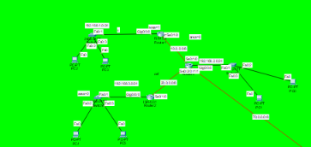

After configuration, the following commands were executed:
show ip ospf neighbor | show ip ospf database | show ip route
These commands verified:
• Neighbor adjacency
• LSDB synchronization
• Route installation

OSPF Results
The routing table successfully displayed OSPF routes marked with the letter O.
Neighbor relationships reached the FULL state.
All routers exchanged Link State Advertisements successfully.

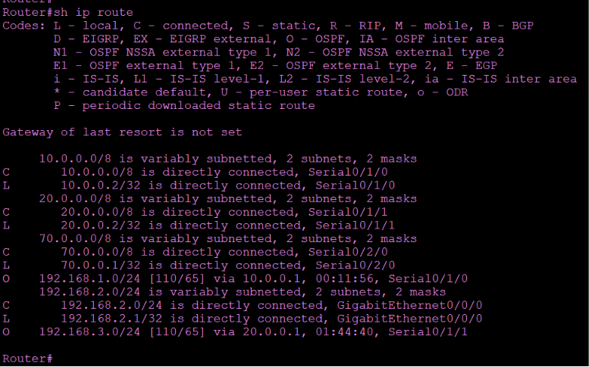

8. EIGRP Implementation
Enhanced Interior Gateway Routing Protocol (EIGRP) was implemented to demonstrate the behavior of Cisco's advanced hybrid routing protocol. Unlike traditional distance-vector protocols, EIGRP utilizes the Diffusing Update Algorithm (DUAL), which provides rapid convergence and loop-free routing decisions.
In this project, all EIGRP routers were configured under the same Autonomous System (AS 100), allowing them to establish neighbor relationships and exchange routing information dynamically.
EIGRP Network Design
The EIGRP routing domain consists of multiple routers interconnected through serial and Ethernet links. Each router advertises its directly connected networks to neighboring routers.
The protocol automatically calculates the best route based on bandwidth and delay metrics.

F
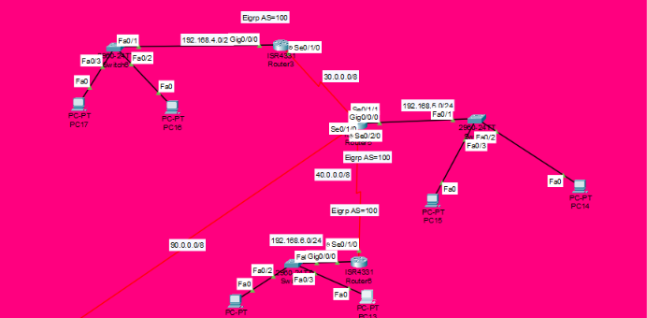

Configuration Steps
The following configuration steps were performed:
- Configure EIGRP Autonomous System 100.
- Advertise all directly connected networks.
- Disable unnecessary auto-summary where required.
- Verify neighbor relationships.
- Verify routing table entries.

Verification
After configuration, the following verification commands were executed:
show ip eigrp neighbors | show ip route | show ip protocols
These commands verified:
- Successful neighbor establishment.
- Route exchange between routers.
- Correct operation of DUAL.
- Dynamic learning of remote networks.
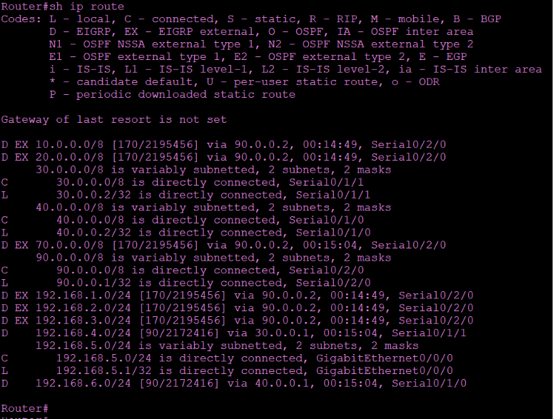
Results
The EIGRP implementation successfully exchanged routing information among all participating routers.
The routing table confirmed that all EIGRP routes were installed correctly, demonstrating proper operation of the protocol.

9. RIP Version 2 Implementation
Routing Information Protocol Version 2 (RIPv2) was implemented to represent a traditional distance-vector routing protocol.
Although RIP is less scalable than OSPF and EIGRP, it remains useful for educational purposes and small networks.
RIPv2 improves upon RIP Version 1 by supporting:
- CIDR
- VLSM
- Multicast updates
- Authentication

RIP Network Design
A separate routing domain was configured using RIP Version 2.
Each router advertised its directly connected networks.
The maximum hop count remained 15, consistent with the RIP standard.

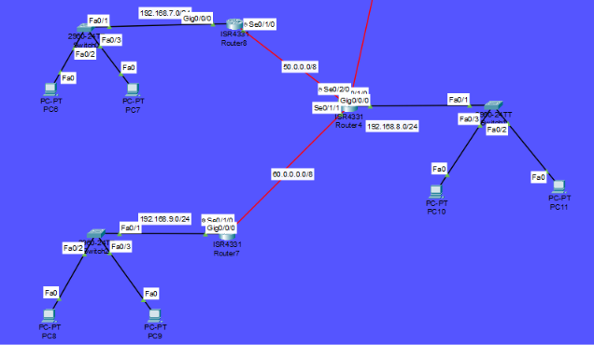

Verification
To verify successful implementation, the following command was used:
show ip route
Routes learned by RIP appeared with the letter: R

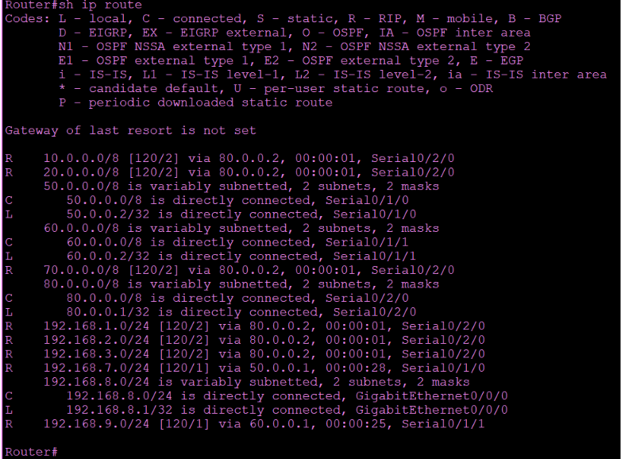

Results
The RIP routing domain successfully exchanged routes.
Connectivity between all RIP routers was confirmed through ICMP testing.

10. Route Redistribution
One of the most important components of this project is route redistribution.
Since OSPF, EIGRP, and RIP belong to different routing domains, they cannot exchange routing information by default.
The Central Router was configured to redistribute routes between all protocols.
This allows devices connected to one routing protocol to communicate with devices using another routing protocol.

Why Route Redistribution?
Without redistribution:
- OSPF routers know only OSPF routes.
- EIGRP routers know only EIGRP routes.
- RIP routers know only RIP routes.
As a result, communication between routing domains would fail.
Redistribution solves this limitation by importing routes from one protocol into another.

Redistribution Configuration
The Central Router performed:
- RIP → OSPF
- OSPF → RIP
- OSPF → EIGRP
- EIGRP → OSPF
This created complete route visibility across all routing domains.

Verification
The following command confirmed successful redistribution:
show ip route
The routing table displayed routes from all protocols simultaneously.

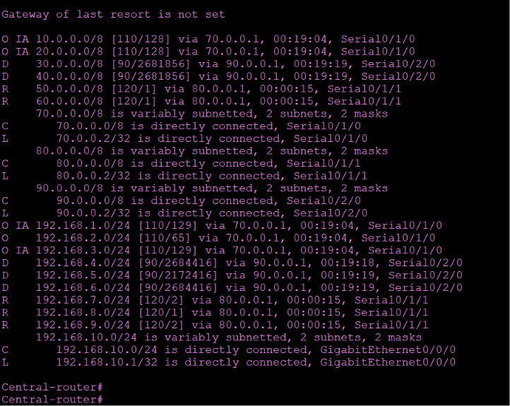
Routing table showing:
- O
- D
- R
appearing together.

Results
Route redistribution was successfully implemented.
All routing domains exchanged routing information through the Central Router, enabling end-to-end communication across the simulated enterprise network.
11. Central Router Architecture
The Central Router represents the core component of the entire network infrastructure. Instead of allowing routing protocols to communicate directly with each other, all routing information passes through this router.
This centralized architecture provides better control over routing decisions, simplifies network management, and allows the administrator to implement security policies and traffic control from a single location.
The Central Router was configured to connect three independent routing domains:
- OSPF Domain
- EIGRP Domain
- RIP Version 2 Domain
Each routing protocol operates independently while the Central Router performs route redistribution to enable communication between all networks.

Advantages of Centralized Routing
The implemented architecture provides several advantages:
- Simplified network management.
- Easier troubleshooting.
- Better scalability.
- Centralized routing policy enforcement.
- Reduced administrative complexity.
- Flexible protocol integration.

12. Secure Remote Management using SSH
Network administrators often need to manage routers remotely.
Using Telnet exposes usernames and passwords in plaintext, making it insecure.
To improve security, Secure Shell (SSH) was configured on the Central Router.
SSH encrypts all communication between the administrator and the router.

SSH Configuration
The following steps were completed:
- Configure hostname.
- Configure domain name.
- Create local username.
- Configure secret password.
- Generate RSA encryption keys.
- Enable SSH Version 1.
- Restrict VTY lines to SSH only.

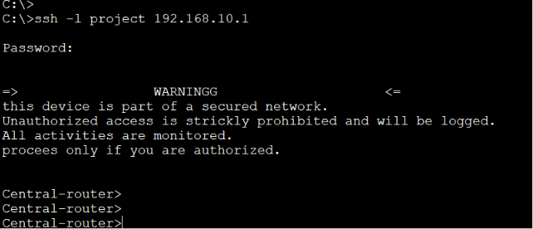

Verification
SSH functionality was verified by connecting remotely using the configured username and password.
The router successfully authenticated the administrator and allowed secure remote configuration.

13. Warning Banner Configuration
To improve network security awareness, a Message of the Day (MOTD) banner was configured.
The purpose of this banner is to warn unauthorized users before granting access to the device.
Such warning messages are commonly deployed in enterprise and government environments.

Importance
The warning banner:
- Informs users that the device is monitored.
- Discourages unauthorized access.
- Supports organizational security policies.
- Provides legal notification before authentication.

14. Access Control Lists (ACL)
Access Control Lists (ACLs) were configured to demonstrate traffic filtering capabilities.
ACLs allow administrators to control which packets are permitted or denied based on defined rules.
They are one of the most fundamental security mechanisms in Cisco networks.

Objectives
The ACL implementation aimed to:
- Restrict unauthorized traffic.
- Control packet forwarding.
- Protect network resources.
- Improve network security.

Results
The ACL successfully filtered network traffic according to the configured rules.
Authorized traffic continued to flow while unauthorized traffic was blocked.

15. Connectivity Testing
After configuring all routing protocols, redistribution, and security features, comprehensive connectivity testing was performed.
The objective was to verify that every subnet could communicate successfully.

Testing Methodology
The following commands were used:
ping
traceroute
Screenshot :Ping from Central-Router to OSPF Router.
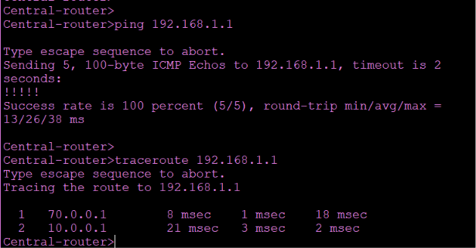
Screenshot: Ping from Central-router to EiGRP Router.
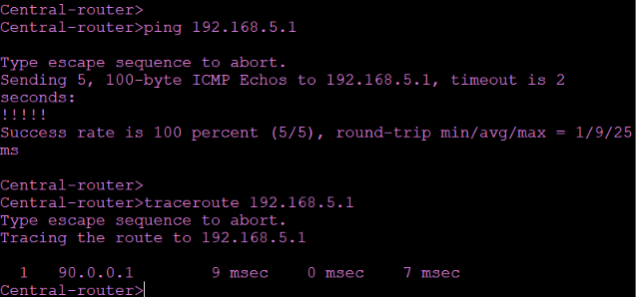

Screenshot: Ping from Central-Router to RIPV2 Router.
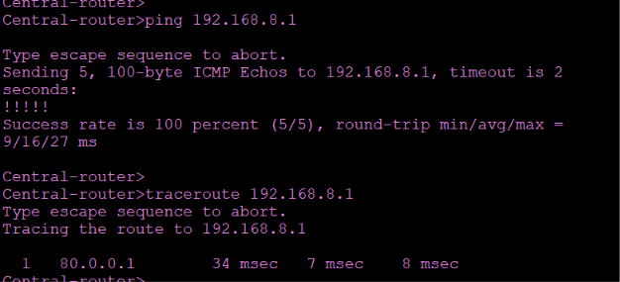

Results
All connectivity tests completed successfully.
Packets were forwarded correctly across different routing domains through the Central Router.
No routing loops or unreachable destinations were observed.

16. Challenges
Several challenges were encountered during the implementation process.
Challenge 1
Different routing protocols cannot exchange routes directly.
Solution
Implemented route redistribution on the Central Router.

Challenge 2
Packet Tracer does not support VXLAN.
Solution
Designed a centralized multi-routing architecture that simulates network segmentation using standard Cisco technologies.

Challenge 3
Managing multiple routing tables simultaneously.
Solution
Used verification commands including :
show ip route| show ip protocols | show ip ospf neighbor | show ip eigrp neighbors

17. Skills Gained
Through this project, practical experience was obtained in:
- Enterprise network design.
- OSPF configuration.
- EIGRP configuration.
- RIP Version 2 configuration.
- Route Redistribution.
- SSH implementation.
- Cisco ACL configuration.
- Network verification.
- Cisco IOS CLI.
- Enterprise troubleshooting.
- Routing table analysis.
- Network security configuration.

18. Conclusion
This project successfully demonstrates the implementation of a centralized enterprise network using multiple dynamic routing protocols.
Although Cisco Packet Tracer does not support VXLAN, the proposed architecture effectively simulates network segmentation by integrating OSPF, EIGRP, and RIP through a Central Router.
Route redistribution enabled seamless communication between different routing domains, while SSH, ACLs, and the warning banner improved the overall security posture of the network.
The project strengthened practical knowledge of routing technologies, protocol interaction, network management, and enterprise-level Cisco configuration.

19. Future Work
Future improvements may include:
- Migrating the project to Cisco CML or GNS3 for full VXLAN support.
- Implementing MP-BGP EVPN.
- Deploying VXLAN Tunnel Endpoints (VTEPs).
- Adding VLAN segmentation.
- Configuring HSRP for gateway redundancy.
- Implementing EtherChannel.
- Integrating Network Monitoring using SNMP.
- Automating configuration using Python and Ansible.
- Deploying Syslog and NetFlow monitoring.
- Adding IPv6 routing support.

